Experiment No .: 1

1. Title: Demonstrate inline, internal, and external
JavaScript; use console methods; create a webpage
showing user info and a welcome message.

2. Software/Tools Required: Visual Studio Code (VS
Code)Google Chrome/web browser, HTML, JavaScript.

3. Theory: JavaScript is a scripting language used to make web
pages interactive.
It can be added in three ways:
● Inline JavaScript: Written inside HTML elements.
● Internal JavaScript: Written inside the <script> tag in the
HTML file.
● External JavaScript: Written in a separate .js file and linked
to the HTML page.
● Console methods like console.log(), console.info(), console.warn(), and console.error() are used for debugging and displaying messages.

4. Output:
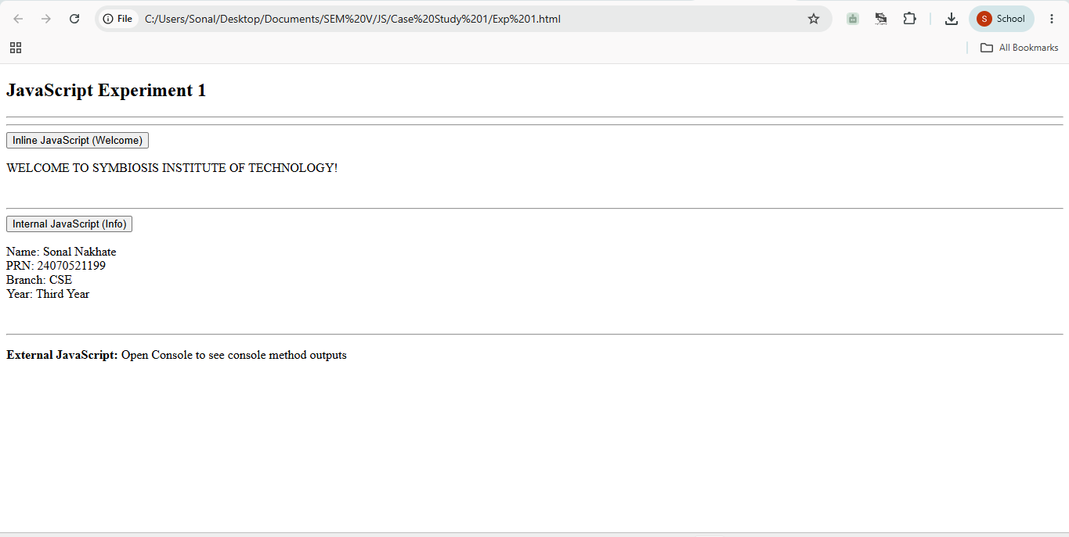

5. Result/Conclusion: The experiment was performed successfully. A webpage displaying a welcome message and user information was created using inline, internal, and external JavaScript, and console methods were demonstrated
successfully.

Case Study No.: 1

1. Case Study Title: Create a webpage for the college department and link the student information page with it. Write a JavaScript program to display "Welcome to SIT Nagpur" in an alert box.

2. Case Study Program Code:
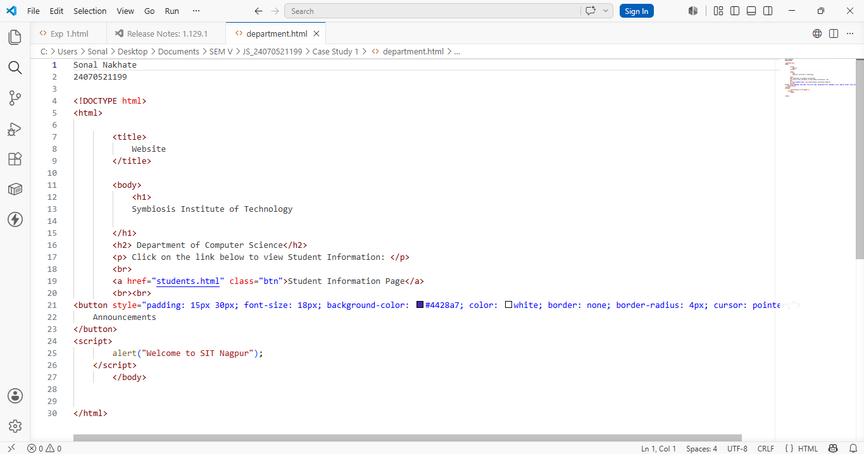

3. Output:
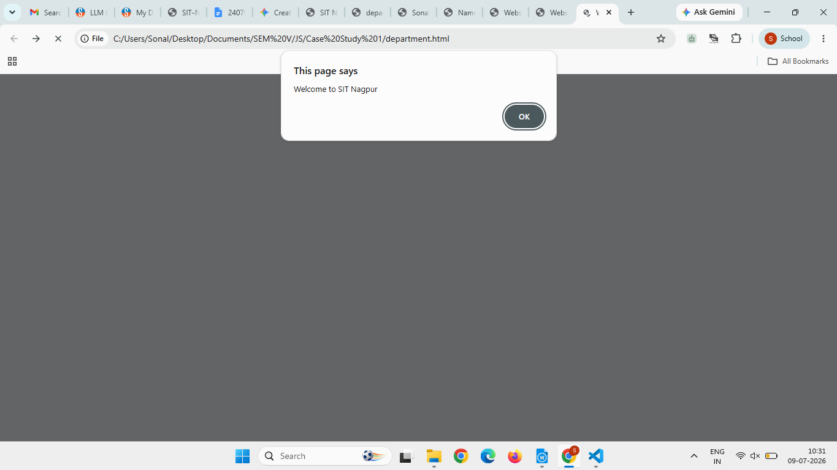
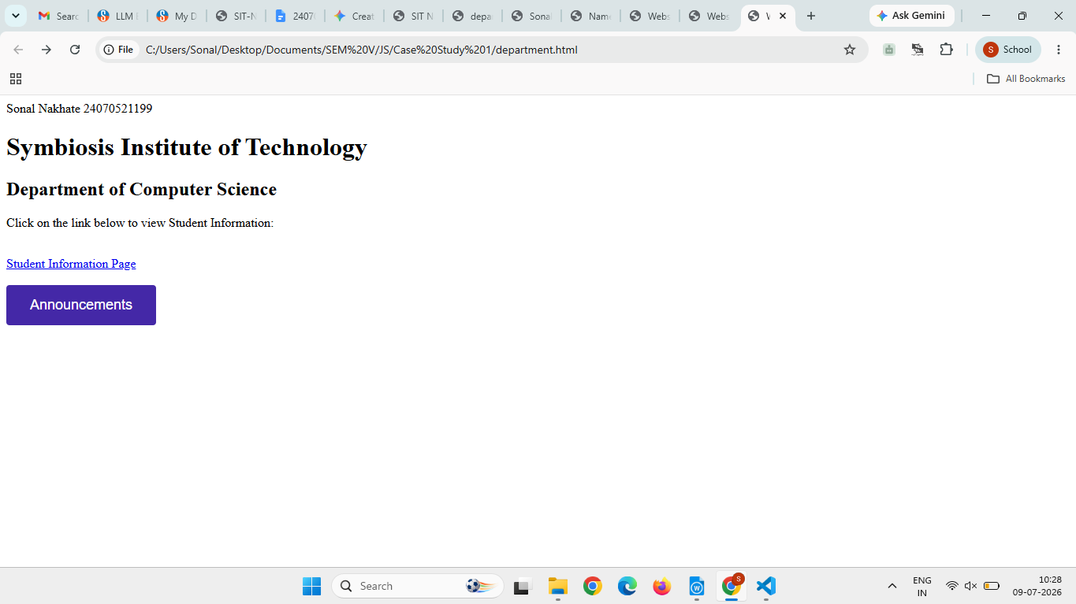

4. Result/Conclusion: The college department webpage was created successfully. The Student Information page was linked to it, and JavaScript was implemented using inline, internal, and external methods. A welcome message was displayed in an alert box, and output was verified in the browser console.

Experiment No.: 2

1. Title: Use var, let, const, and demonstrate basic features like
template literals and destructuring; build a billing calculator
with user input.

2. Software/Tools Required: Visual Studio Code (VS Code), web
browser, HTML, JavaScript.

3. Theory: var is function-scoped, let is block-scoped, and const is used for fixed values.
The prompt() function accepts user input, and Number() converts input into numeric values.
The program calculates the total amount, GST, and final bill using arithmetic operations.
An object stores all billing details together, while object
destructuring extracts required values easily.
Template literals (``) are used to display formatted output with variable values using ${}.
The document.write() method displays the billing receipt on the webpage.

4. Output: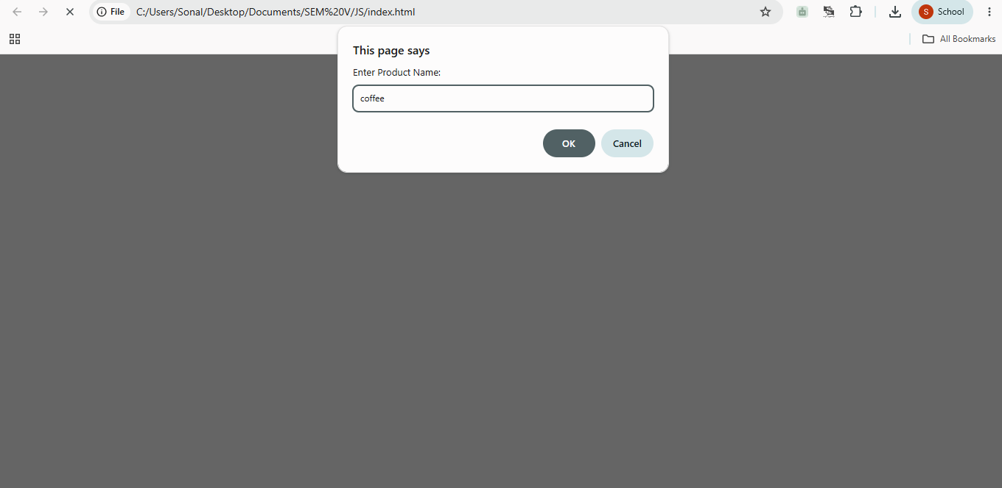
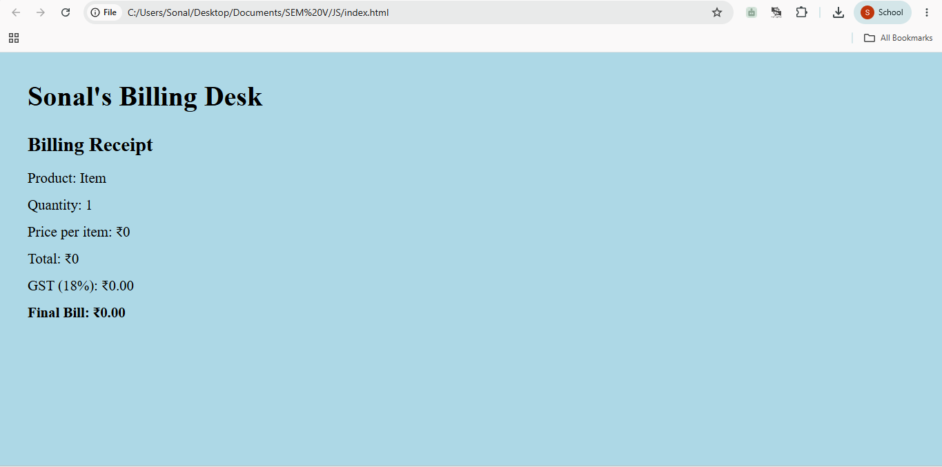
5. Result/Conclusion: A billing calculator was successfully created using JavaScript. The program accepted user input, calculated the bill with GST, and demonstrated the use of var, let, const, template literals, and object destructuring
effectively.

Case Study No.: 2

1. Case Study Title: Develop the webpage for an online shopping website using HTML, CSS, and HTML tags and calculate the bill, customer name, mobile number, invoice number, product number, quantity (kg), rate per kg, discount, GST, packing charges, payment mode (cash/card/UPI), and membership (yes/no).

2. Case Study Program Code:
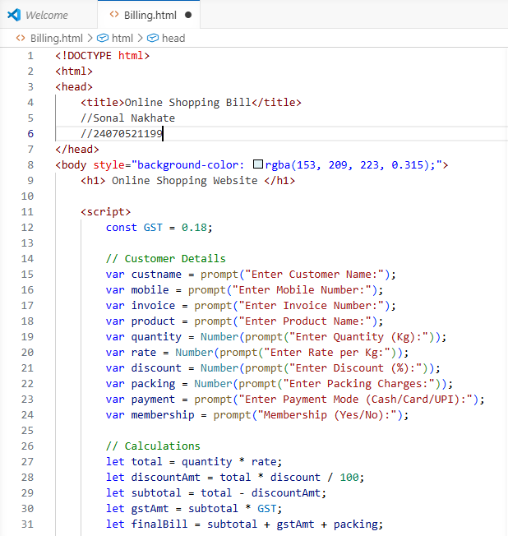
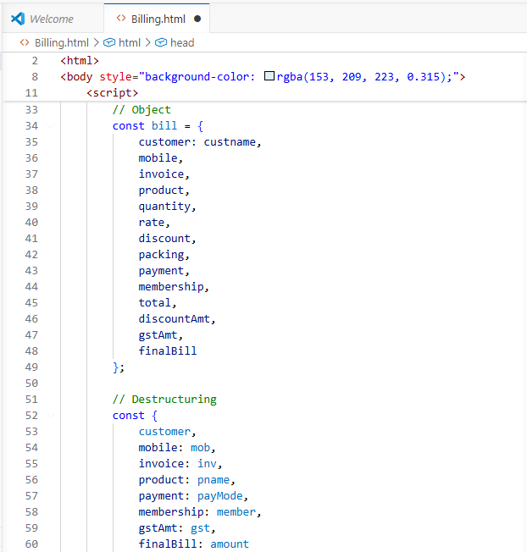
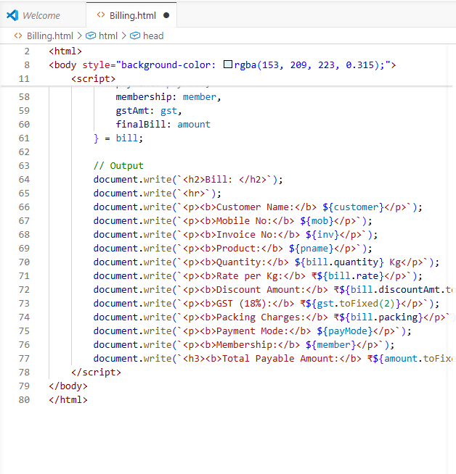

3. Output:
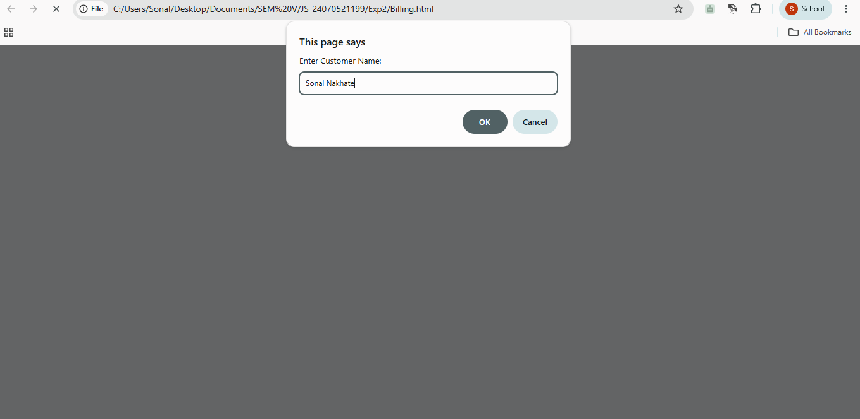
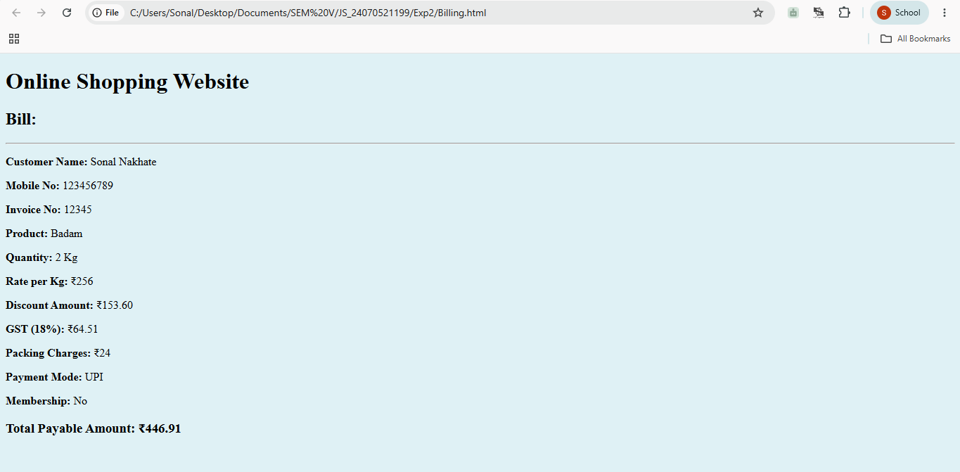

4. Result/Conclusion: The online shopping billing webpage was successfully developed using HTML, CSS, and JavaScript. The program accepted customer and product details; calculated the total bill, including discount, GST, and packing charges; and displayed the final invoice correctly. It demonstrated the use of user input, arithmetic calculations, objects, template literals, and object destructuring in JavaScript.

Experiment No.: 3

1. Title: Implement control structures and form validation. Create a grading system based on user-entered marks.

2. Software/Tools Required: Visual Studio Code (VS
Code) Google Chrome/web browser, HTML, JavaScript.

3. Theory:

A. Form Validation
Ensures user input is accurate and valid before processing.
- Empty Check: Ensures the input field is not blank.
- Type Check: Ensures input is a number using isNaN().
- Range Check: Restricts marks within valid bounds.

B. Control Structures (if...else if...else)
Executes specific blocks of code depending on whether conditions evaluate to true or false. Used to map mark ranges to grades.

C. DOM Manipulation
- Input: document.getElementById('marks').value (Reads input).
- Output: document.getElementById('result').innerText (Displays output).

4. Output:
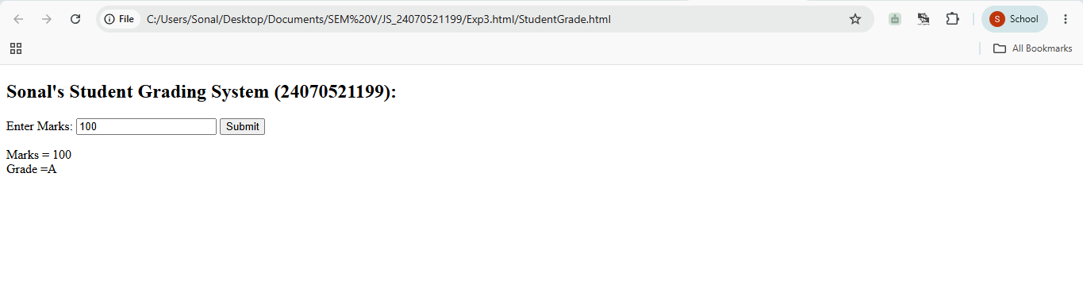
5. Result/Conclusion: By using control structures (if...else if) alongside form validation techniques, web applications can accurately process user inputs, prevent faulty data processing, and produce dynamic, real-time results such as student grading reports.

Case Study No.: 3

1. Case Study Title: Write a JavaScript program that accepts student marks and displays the scholarship category.

2. Case Study Program Code:
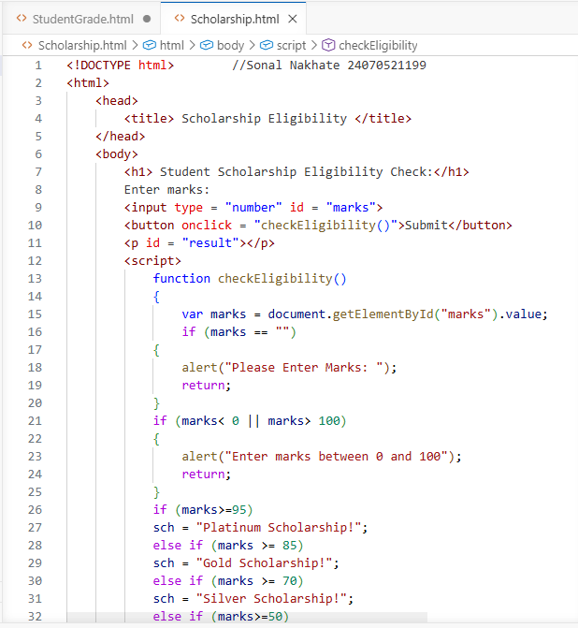
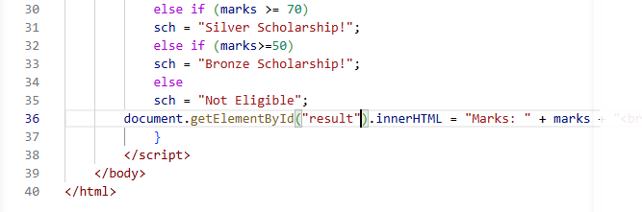

3. Output:
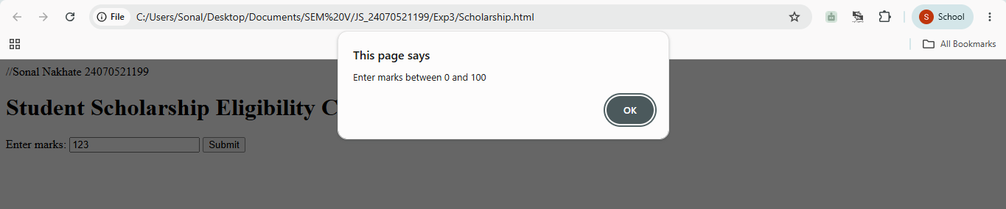
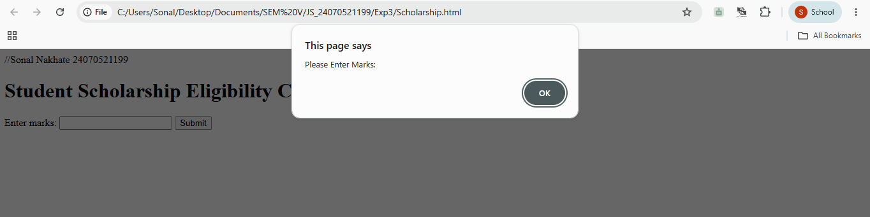
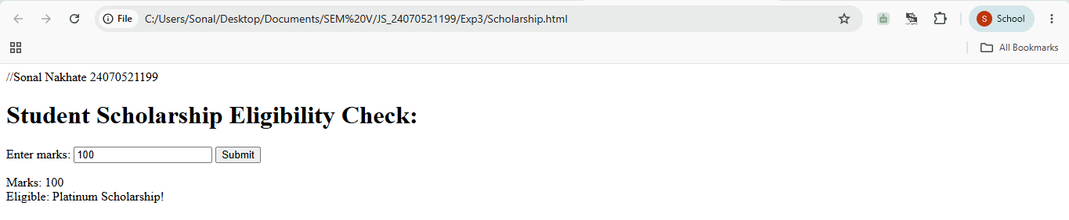
4. Result/Conclusion: We have successfully implemented a simple JavaScript program that checks scholarship eligibility based on marks scored by the student.

Experiment No.: 4
1. Title: Use function types, scope, and closures; apply try-catch; build a palindrome checker.
2. Software/Tools Required: Visual Studio Code (VS Code) Google Chrome/web browser, HTML, JavaScript.
3. Theory:
Function Types: Demonstrates anonymous functions (assigned directly to variables without a name) and arrow functions (concise ES6 => syntax).
Scope: Differentiates between global variables (accessible throughout the script) and local variables (restricted to the block
or function where they are declared).
Closures: Occurs when an inner function retains access to its parent function's scope, preserving state variables (like count) even after the outer function finishes executing.
Error Handling: Uses try...catch and throw statements to validate input types and gracefully handle runtime exceptions without crashing the program.
Palindrome Algorithm: A string is split into an array of characters, reversed, joined back into a string, and compared against the original input using strict equality (===).
4. Output:
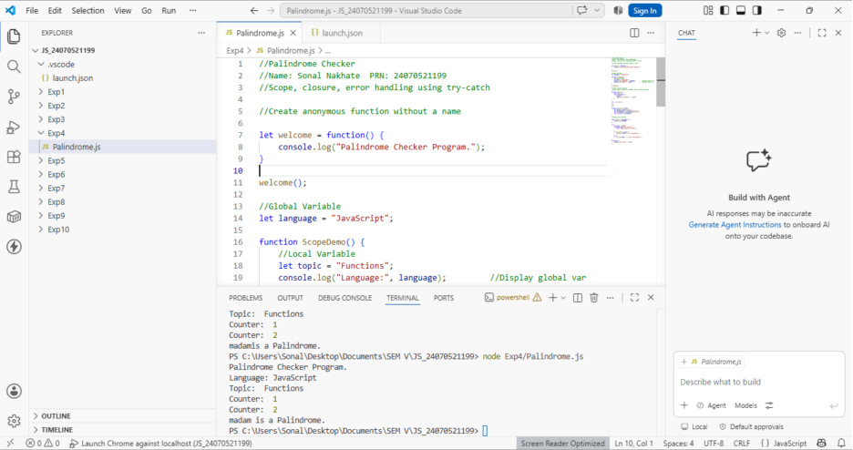

5. Result/Conclusion: In this experiment, fundamental JavaScript concepts—including anonymous/arrow functions, scope rules, closures, and try...catch error handling—were successfully implemented. Using these techniques alongside array manipulation methods (split, reverse, join), a functional and error-resistant palindrome checker was constructed.

Case Study No.: 4
1. Case Study Title: ATM Card Pin Verification using JavaScript Functions Case Study.
2. Case Study Program Code:
// Global Scope: System configurations //Name: Sonal Nakhate PRN: 24070521199 const BANK_NAME = "Global Secure Bank"; let dailyAttemptsLimit = 3;

// 1. FUNCTION DECLARATION: Reverses a PIN string or number function reversePin(pin) {
const pinString = String(pin);
const reversed = pinString.split("").reverse().join(""); return reversed;
}

// 2. FUNCTION EXPRESSION: Checks if a PIN is a palindrome const isPalindromePin = function(pin) {
const pinString = String(pin);
const reversedPin = reversePin(pinString); return pinString === reversedPin;
};
// 3. ARROW FUNCTION: Formats output messages based on verification const generateSecurityAlert = (pin, isPalindrome) => {
if (isPalindrome) {
return `[SPECIAL SECURITY PROTOCOL]: PIN ${pin} is a Palindrome. High-symmetry alert triggered. Proceeding to main menu...`;

return `[STANDARD SECURITY]: PIN ${pin} verified successfully. Proceeding to main menu...`;
};

// 4. SCOPE DEMONSTRATION: Verification Handler function processATMTransaction(enteredPin) {
let attemptCounter = 1;

console.log(`--- Processing PIN verification at ${BANK_NAME} ---`);

if (attemptCounter <= dailyAttemptsLimit) {
const isPalindromic = isPalindromePin(enteredPin);
const securityMessage = generateSecurityAlert(enteredPin, isPalindromic);
console.log(securityMessage);

// FIXED OBJECT RETURN: Comma added after true return success: true,
isPalindrome: isPalindromic };
} else {
console.log("Account locked. Exceeded daily limits."); return {
success: false, isPalindrome: false
};
}
}
//Execution processATMTransaction(1221); processATMTransaction(4821);

3. Output:
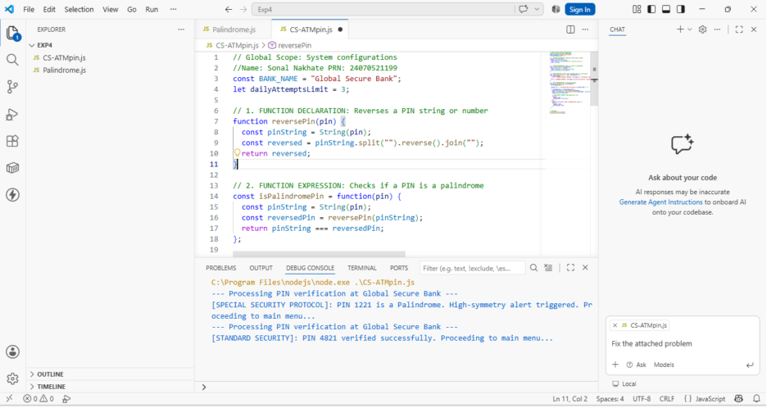

4. Result/Conclusion: We have successfully implemented a simple JavaScript program that checks if the ATM pin is a palindrom or not.

Experiment No.: 5

1. Title: Apply array methods and object handling; create a cart total calculator with discount logic.

2. Software/Tools Required: Visual Studio Code (VS
Code), JavaScript.

3. Theory:
JavaScript objects allow storing collections of data using key-value pairs (e.g., name, price, quantity), while arrays store ordered lists of these objects. Higher-order array methods such as reduce() process elements systematically without standard explicit loops. The reduce() method executes a reducer function on each array element, accumulating values to compute a single output—such as the total cost of all products. Conditional statements (if-else or ternary operators) evaluate business logic, such as applying a 10% discount if the cart's total exceeds a specific threshold.

4. Output:
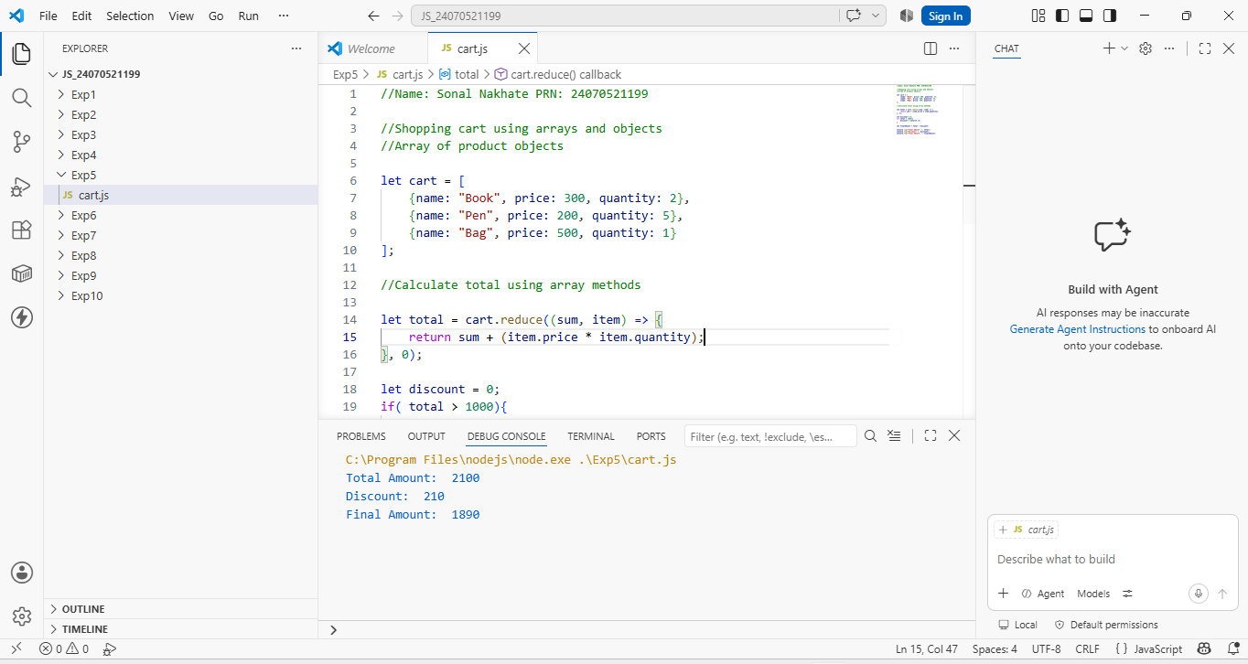
5. Result/Conclusion: The experiment was performed successfully. JavaScript arrays, objects, and higher-order array methods (specifically reduce()) were demonstrated to process structured data efficiently. Conditional logic for applying discounts was implemented, and the final output was verified using browser console.log() methods.

Case Study No.: 5

1. Case Study Title: To study the functioning of arrays and loops in JavaScript.
Create and manipulate arrays: push, pop, shift, unshift, splice, slice.
Use array methods: map(), filter(), reduce(), and forEach().
Create an array of numbers and find the maximum and minimum values.

2. Case Study Program Code:
//Sonal Nakhate 24070521199

// 1. Create an Array
let fruits = ["apple", "banana", "cherry"];

// push() - Adds an element to the END
fruits.push("mango");
// Result: ["apple", "banana", "cherry", "mango"]

// pop() - Removes the LAST element
let lastFruit = fruits.pop();
// Result: ["apple", "banana", "cherry"] | Removed: "mango"

// unshift() - Adds an element to the BEGINNING
fruits.unshift("strawberry");
// Result: ["strawberry", "apple", "banana", "cherry"]

// shift() - Removes the FIRST element
let firstFruit = fruits.shift();
// Result: ["apple", "banana", "cherry"] | Removed: "strawberry"

// splice(startIndex, deleteCount, ...itemsToAdd) - Modifies original array (Mutates)
// Example: Remove 1 element at index 1 and insert "grape"
fruits.splice(1, 1, "grape");
// Result: ["apple", "grape", "cherry"]

// slice(startIndex, endIndex) - Extracts a portion WITHOUT modifying original (Non-mutating)
// Note: endIndex is non-inclusive
let subArray = fruits.slice(0, 2);
// subArray: ["apple", "grape"]
// fruits stays: ["apple", "grape", "cherry"]

const numbers = [1, 2, 3, 4, 5, 6];

// 1. forEach() - Executes a function once for each array element (returns nothing)
numbers.forEach((num) => {
console.log(`Item: ${num}`);
});

// 2. map() - Creates a NEW array by transforming every element
const doubled = numbers.map((num) => num * 2);
// Result: [2, 4, 6, 8, 10, 12]

// 3. filter() - Creates a NEW array with elements that satisfy a condition
const evens = numbers.filter((num) => num % 2 === 0);
// Result: [2, 4, 6]

// 4. reduce() - Accumulates array elements down to a SINGLE value
// Syntax: array.reduce((accumulator, currentValue) => ..., initialValue)
const sum = numbers.reduce((acc, curr) => acc + curr, 0);
// Result: 21

const nums = [42, 7, 89, 12, 3, 99, 23];

const maxVal = Math.max(...nums); // 99
const minVal = Math.min(...nums); // 3

console.log(`Max: ${maxVal}, Min: ${minVal}`);

3. Output:
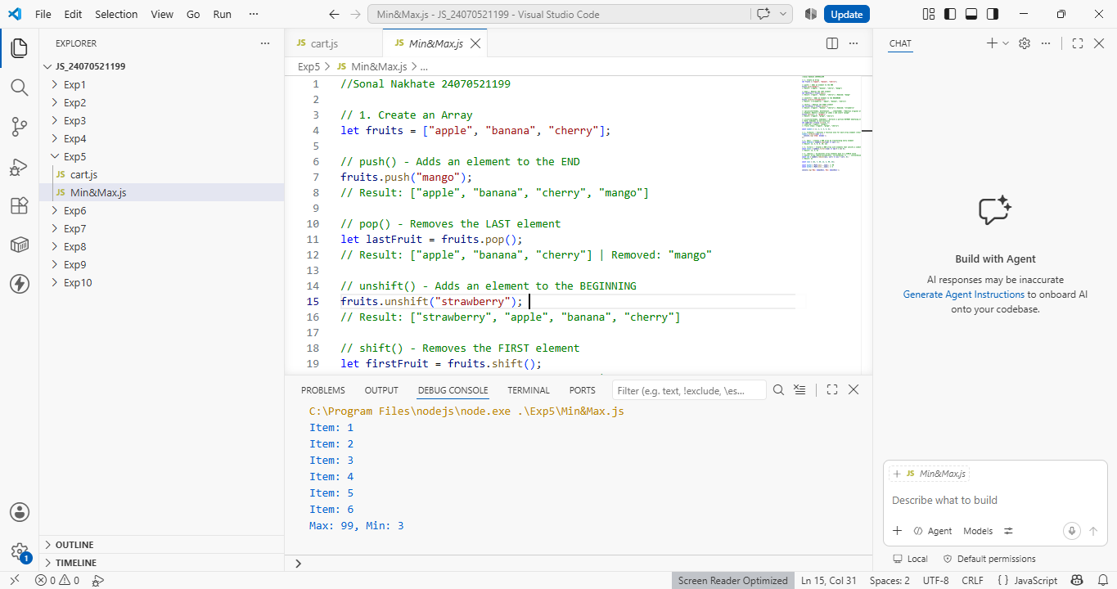

4. Result/Conclusion: This experiment demonstrated the core mechanics of JavaScript arrays and iterative processing. Highlighting how different methods handle data manipulation, transformation, and evaluation. Modifying arrays using push(), pop(), shift(), unshift(), splice(), and slice() established a practical understanding of element positioning and the distinction between mutating original data versus returning new copies. Furthermore, utilizing functional array methods like forEach(), map(), filter(), and reduce() illustrated a clean, declarative alternative to traditional looping for transforming and aggregating data. Finally, calculating the maximum and minimum values of a number array using Math.max()/Math.min() with the spread operator, reduce(), and classic for loops demonstrated how algorithmic logic and modern language features can solve fundamental computational problems efficiently.

